CURRICULUM VITAE
Professor Mukesh Mathur  Dean & Chairman  Faculty of Commerce  Department of Banking & Business Economics, University College of Commerce & Management Studies, Mohanlal Sukhadia University, Udaipur  M. Com, M.Phil., Ph.D; | 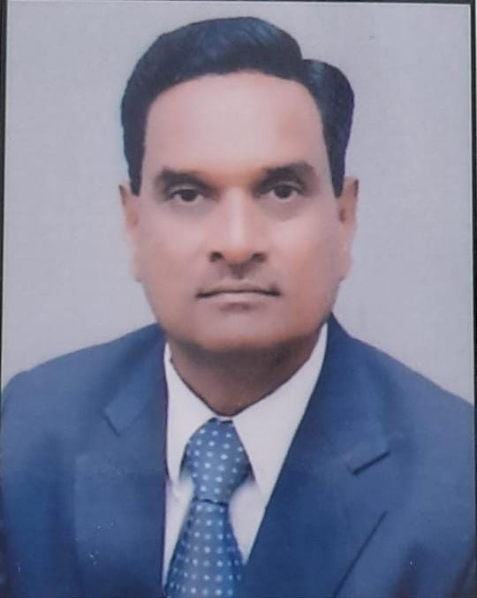

ACADEMIC RECORD
S. No. | Exam Passed | University | Subjects | Year
1. | B.SC | University of Rajasthan | Science | 1984
2. | M.COM. | University of Rajasthan | E.A.F.M. | 1986
3. | M.Phil | University of Rajasthan | E.A.F.M. | 1987
4. | Ph.D. | University of Rajasthan | E.A.F.M. | 1990

Area of Expertise
- Knowledge in teaching of Business economics, Indian Financial System, Economic Environment & have also 24 research scholars in last 32 years of experience.
- Co-ordinated in Conducting, Moderating, and Marking of Required Assessments, Tests, Projects, and Examinations.
- Well versed with Modern Teaching Pedagogy like Moodle & Interactive Panel, Flip Classes and OBE.

Experience
- Presently working as Professor in University College of Commerce & Management Studies, Mohanlal Sukhadia University, Udaipur, Rajasthan from the year 1991 and has 32 years of experience.

RESEARCH, PUBLICATION AND ACADAMIC CONTIMUTIONS
- Published papers in Journals
S.No. | Title with page nos. | Journal | ISSN/ ISBN No.
1 | An Evaluation of Factors Impacting Investment Decisions of Working Women | International Journal of Research and Analytical Reviews (IJRAR). 2023 | E- ISSN 2348-1269, Vol 10 Issue 2.
2 | A study on Financial Behaviour of Female Students | Anvesak 2022 | ISSN: 0378-4568  vol 52 No 1(1),
3 | Analytical study of Saving, Investment and Borrowing of Indian Households | The Journal of Oriental Research, 2022 | ISSN: 0022-3301  Vol XCIII-I, 2
4 | Customer Expectation & perception with enabled services of Banks : An empirical study of Udaipur  Kanpur Philosophy | International Journal of Humanities Law and Social Science  Vol 1x2022 | ISSN 2348-8301
5 | An analytical study of motivation factors that influence women to become entrepreneurs in Rajasthan | International Journal of Humanities Law and Social Science, 2022 | ISSN 2348-8301  Vol IX, Issue X, October 2022
6 | Role Of Micro Finance In Financial Inclusion: The Impact Of SHG-BLP And Micro Finance Institutions | Inspira- Journal of Modern Management & Entrepreneurship (JMME), 140  January, 2020, | ISSN: 2231-167X, GIF: 2.7282, CIF: 5.647, Volume 10, No. 01, pp. 140-144
7 | Customer Satisfaction with various Banking Services – A Study of ICICI Bank’s customer of Udaipur city. | International Journal of Modern Management and entrepreneurship, 2015 | ISSN 2231-167x Vol 03, No 01, Jan 2015 p.p. 33-43
8 | Use of IT in Retail Banking | Advet Institute of Management Studies, 2011 | ISSN No. 0974-2581 Sept. 10-11 Feb
9 | Mobile Banking A New Dimension of Banking | Amity Business Review Vol 111  01 Jan –June 2010 | 0972-2343 Page-25
10 | Emergence of Retail Banking in India, 8-10 | Southern Economist (Banglore) December 2009 | 0038-4046
11 | Electronic Clearing Services in Indian Banks 87-91 | Amity Business Review Noida Jan-June 2009 | 0972-2343 Referred Journal
12 | efgykvksa ds vkfFkZd fodkl esa cSadks dh Hkwfedk dk rqyukRed v/;;u 11&18 | Social Research Badlav Sansthan, Udaipur – 2009 | 0973-1210
13 | Emergence of Universal Banking in India, 39-40 | Southern Economist (Banglore) February 15,2007 | 0038-4046
14 | Changing Scenario of Commercial Banks & Role of IT, 15-17 | Southern Economist (Banglore) October 15,2007 | 0038-4046
15 | Mutual Fund Industry in India : An analysis 29-30 | Southern Economist (Banglore) August 1, 2006 | 0038-4046
16 | Rural Orientation of Indian Banking 81-85 | Indian Journal of Enterprise (Allahabad) June 2005 | Approved
17 | Progress & Performers of LIC of India 28-31 | Indian Journal of Enterprise (Allahbad) Dec. 2003 | Approved
18 | Importance of financial intermediaries of Indian Economy 10-12 | Southern Economist (Banglore) June 15,2002 | 0038-4046
19 | Mobile Banking : The Best Custom Service Tool for the Banks to Retail Customs | Page 71 ISSN No. 974-438X Vol 3 Oct-Dec 2000
20 | Role and Contribution of RRB’s | The Corporation Page 118 Sept 15, 1990
21 | Mobile Banking Processor and Problems | Pacific Business Review International | 0974-438X Page 99

B (i) Books Published / Chapters Published in Books
S.No. | Title with page nos. | Books Title. Editor & Publisher | ISSN/ ISDN No.
1 | Indian Financial System, 307 | Himanshu Publication, Udaipur 2009 | 978-81-7906138-1
2 | Social & Cultural Environment Unit-2 Page – 09 -18 | Vavsayik Vatavarn M.com.-02 VMO University, Kota, March -2009 | ISBN 13/97881-8496-005-1
3 | 08 Chapters | Mudra Evam Vitya Pranali, Apex Publishing House, Udaipur, 2007-08 | ISBN 81-301-0046-0
4 | Unit-1 & 2, 1 to 82 | Aarthik Evam Vitya Adhyan, edited by Prof. M.D. Agarwal, Board of Sec. Edu. Rajasthan, Ajmer-2003
5 | 10 Chapters | Business Economics wide Vision, Jaipur 2003 | ISBN 81-8068-014-2

BOOKS

S.No. | Book Name | Year | Publication House
1 | Indian Financial System | 2023 | Himanshu Publications, Udaipur
2 | Hkkjrh; foRrh; iz.kkyh | 2023 | Himanshu Publications, Udaipur
3 | Hkkjrh; foRrh; O;oLFkk | 2019 | Himanshu Publications, Udaipur
4 | vkfFkZd fo’ys"k.k | 2017 | Himanshu Publications, Udaipur
5 | O;olkf;d vFkZ’kkL= | 2016 | fgUnh xzaFk vdkneh] t;iqj
6 | varjkZ"Vh; O;kikj ,oa for | 2016 | Himanshu Publications, Udaipur
7 | Indian Financial System | 2015 | Himanshu Publications, Udaipur
8 | Banking Law & Practice | 2015 | Himanshu Publications, Udaipur
9 | foRrh; vFkZ’kkL= | 2014 | Himanshu Publications, Udaipur
10 | Ekqnzk ,oa foRrh; iz.kkyh | 2014 | fgUnh xzaFk vdkneh] t;iqj
11 | Money and Financial System | 2014 | Himanshu Publications, Udaipur
12 | Business Economics | 2014 | Himanshu Publications, Udaipur
13 | Emerging Trend in Economic Environment | Edited 2012 | Himanshu Publications, Udaipur
14 | Indian Bnaking System | 2010 | Himanshu Publications, Udaipur
15 | eqnzk cSfdax jktLo ,oa fons’kh fofu;e | 1998 | Himanshu Publications, Udaipur

Key Strengths
- Profound knowledge of the subject areas and ability to teach students by using various methods

5. Personal Information

Name | Prof. Mukesh Mathur
Designation | Dean & Chairman, Faculty of Commerce  Dept. of Banking and Business Economics,  UCCMS, MLSU, Udaipur (Raj.)
Father Name | Sh. A.L. Mathur
Category | General
Address (Permanent) | 29, New Keshav Nagar, Udaipur, Rajasthan  Pin code: 313001
Address (Correspondent) | 29, New Keshav Nagar, Udaipur, Rajasthan  Pin code: 313001
Contact | +91-7427093416
E-Mail | Mmathur1964@gmail.com
Date of Birth | 01.02.1964
Marital Status | Married

(Prof. Mukesh Mathur)

